# Provisioning SonarQube & Jenkins

~/sonarqube-ansible/

├── site.yml

└── roles/

├── java/

│ └── tasks/main.yml

├── postgresql/

│ └── tasks/main.yml

└── sonarqube/

└── tasks/main.yml

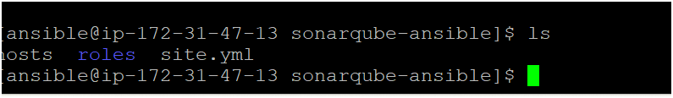



[webservers]

172.31.43.232 ansible_user=ansible ansible_ssh_private_key_file=/home/ansible/.ssh/id_rsa

============================

Site.yml

---

- name: Provision SonarQube Server

hosts: webservers

user: ansible

become: yes

connection: ssh

roles:

- java

- postgresql

- sonarqube

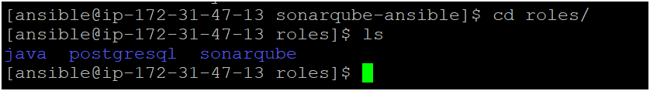

Cd roles/java/tasks/main.yml

- name: Install Amazon Corretto 17 (OpenJDK 17)

package:

name: java-17-amazon-corretto

state: present

====================================================

Cd roles/ postgresql /tasks/main.yml

---

- name: Install PostgreSQL 15 server and client

dnf:

name:

- postgresql15

- postgresql15-server

state: present

- name: Initialize PostgreSQL DB manually

become_user: postgres

command: /usr/bin/initdb -D /var/lib/pgsql/data

args:

creates: /var/lib/pgsql/data/PG_VERSION

- name: Enable and start PostgreSQL service

systemd:

name: postgresql

state: started

enabled: yes

- name: Create sonar user

become_user: postgres

shell: psql -tc "SELECT 1 FROM pg_roles WHERE rolname='sonar'" | grep -q 1 || psql -c "CREATE USER sonar WITH PASSWORD 'sonar';"

- name: Create SonarQube database

become_user: postgres

shell: psql -tc "SELECT 1 FROM pg_database WHERE datname = 'sonarqube'" | grep -q 1 || psql -c "CREATE DATABASE sonarqube OWNER sonar;"

========================================================

Cd roles/ sonarqube /tasks/main.yml

---

- name: Install dependencies

dnf:

name:

- unzip

- wget

state: present

- name: Create sonar user

user:

name: sonar

shell: /bin/bash

create_home: yes

- name: Download SonarQube

get_url:

url: https://binaries.sonarsource.com/Distribution/sonarqube/sonarqube-10.4.1.88267.zip

dest: /opt/sonarqube.zip

- name: Unzip SonarQube

unarchive:

src: /opt/sonarqube.zip

dest: /opt/

remote_src: yes

- name: Rename extracted folder

command: mv /opt/sonarqube-10.4.1.88267 /opt/sonarqube

args:

creates: /opt/sonarqube/bin

- name: Change ownership

file:

path: /opt/sonarqube

owner: sonar

group: sonar

recurse: yes

- name: Configure SonarQube to use PostgreSQL

lineinfile:

path: /opt/sonarqube/conf/sonar.properties

regexp: '^#sonar.jdbc.url'

line: sonar.jdbc.url=jdbc:postgresql://localhost/sonarqube

- name: Set DB username

lineinfile:

path: /opt/sonarqube/conf/sonar.properties

regexp: '^#sonar.jdbc.username'

line: sonar.jdbc.username=sonar

- name: Set DB password

lineinfile:

path: /opt/sonarqube/conf/sonar.properties

regexp: '^#sonar.jdbc.password'

line: sonar.jdbc.password=sonar

- name: Create systemd service

copy:

dest: /etc/systemd/system/sonarqube.service

content: |

[Unit]

Description=SonarQube service

After=syslog.target network.target

[Service]

Type=forking

ExecStart=/opt/sonarqube/bin/linux-x86-64/sonar.sh start

ExecStop=/opt/sonarqube/bin/linux-x86-64/sonar.sh stop

User=sonar

Group=sonar

Restart=always

LimitNOFILE=65536

LimitNPROC=4096

[Install]

WantedBy=multi-user.target

- name: Reload systemd

systemd:

daemon_reload: yes

- name: Enable and start SonarQube

systemd:

name: sonarqube

enabled: yes

state: started

=================================================

# provision Jenkins

jenkins-ansible/

├── hosts

├── site.yml

└── roles/

└── jenkins/

└── tasks/

└── main.yml

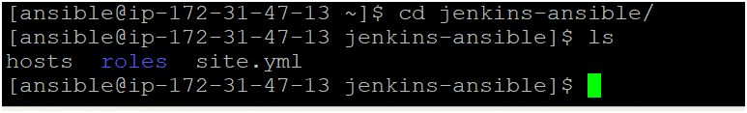

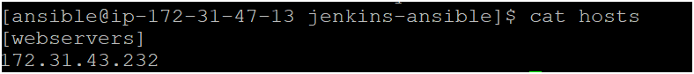

[webservers]

172.31.43.232

Site.yml

---

- name: Provision Jenkins Server

hosts: webservers

become: true

roles:

- Jenkins

=========================

Cd jenkins-ansible/roles/jenkins/tasks

Main.yml

---

- name: Install required system packages

dnf:

name:

- java-17-amazon-corretto

- wget

- git

state: present

- name: Add Jenkins repo key

rpm_key:

key: https://pkg.jenkins.io/redhat-stable/jenkins.io.key

state: present

- name: Add Jenkins repo

get_url:

url: https://pkg.jenkins.io/redhat-stable/jenkins.repo

dest: /etc/yum.repos.d/jenkins.repo

- name: Install Jenkins

dnf:

name: jenkins

state: present

- name: Enable and start Jenkins service

systemd:

name: jenkins

state: started

enabled: yes